- Applications of Set Similarity
  - Jaccard Similarity of Sets and Jaccard Distance
  - Similarity of Documents
    - Plagiarism
    - Mirror Pages
    - Articles from same source
  - Collaborative Filtering as a Similar-Sets Problem
    - Online purchases
    - Movie ratings (If binary use Jaccard Similarity, if not use JS for bags)
    - Jaccard similarity for bags max is 1/2
- Shingling of Documents
  - k-Shingles
    - Suppose our document D is the string abcdabd, and we pick k = 2. Then the set of 2-shingles for D is {ab, bc, cd, da, bd}. If ab is repeated twice, then it is a bag and not a shingle
    - If we use k = 9, but eliminate whitespace altogether, then we would see some lexical similarity in the sentences “The plane was ready for touch down”. and “The quarterback scored a touchdown”. However, if we retain the blanks, then the first has shingles touch down, while the second has touchdown. If we eliminated the blanks, then both would have touchdown.
  - Choosing the Shingle Size – if k is small, the similarity would be high but documents would not actually be similar k should be picked large enough that the probability of any given shingle appearing in any given document is low.

For mails, k=5 is appropriate while for research articles, k=9 or 10 is safe
  - Hashing Shingles
Instead of using substrings directly as shingles, we can pick a hash function
that maps strings of length k to some number of buckets and treat the resulting
bucket number as the shingle.
  - Shingles Built from Words (stop words) – To find similar news articles

An ad might have the simple text “Buy Sudzo.” However, a news article with the same idea might read something like “A spokesperson for the Sudzo Corporation revealed today that studies have shown it is good for people to buy Sudzo products.” Here, we have italicized all the likely stop words, although there is no set number of the most frequent words that should be considered stop words. The first three shingles made from a stop word and the next two following are:
A spokesperson for
for the Sudzo
the Sudzo Corporation
There are nine shingles from the sentence, but none from the “ad.”
The ad is: Buy Sudzo.

It contains only two words and no stop words such as "a", "the", "for", "to", etc.
Since the shingling method starts from stop words, there is nothing to generate.
Therefore:
- News article: 9 shingles generated.
- Ad: 0 shingles generated.

Exercises
- Find the Jaccard Similarity
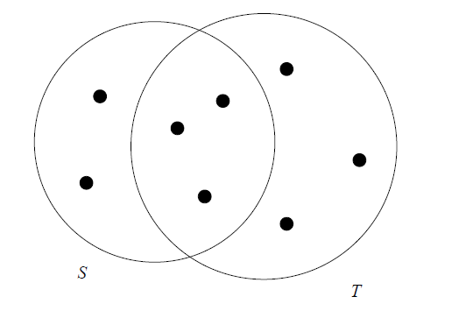
- The bag-similarity of bags {a, a, a, b} and {a, a, b, b, c} is 1/3.
- Exercise 3.1.1 : Compute the Jaccard similarities of each pair of the following three sets: {1, 2, 3, 4}, {2, 3, 5, 7}, and {2, 4, 6}.
- Exercise 3.1.2 : Compute the Jaccard bag similarity of each pair of the following three bags: {1, 1, 1, 2}, {1, 1, 2, 2, 3}, and {1, 2, 3, 4}.
- What are the first ten 3-shingles in the first sentence “The plane was ready for touch down”.
- If we use the stop-word-based shingles of Section 3.2.4, and we take the stop words to be all the words of three or fewer letters, then what are the shingles in the first sentence “The plane was ready for touch down”.

Similarity-Preserving Summaries of Sets
- replace large sets by much smaller representations called “signatures.”
- we can compare the signatures of two sets and estimate the Jaccard similarity of the underlying sets from the signatures alone.

In Fig. 3.2 is an example of a matrix representing sets chosen from the universal set {a, b, c, d, e}. Here, S1 = {a, d}, S2 = {c}, S3 = {b, d, e}, and S4 = {a, c, d}.

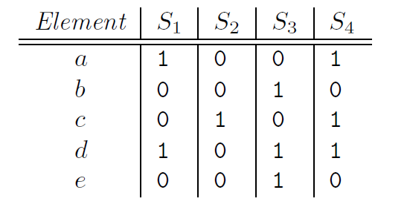

Compute Signatures for the above table using the hash v alues given below.
(a) h3(x) = 2x + 4 mod 5.
(b) h4(x) = 3x − 1 mod 5.
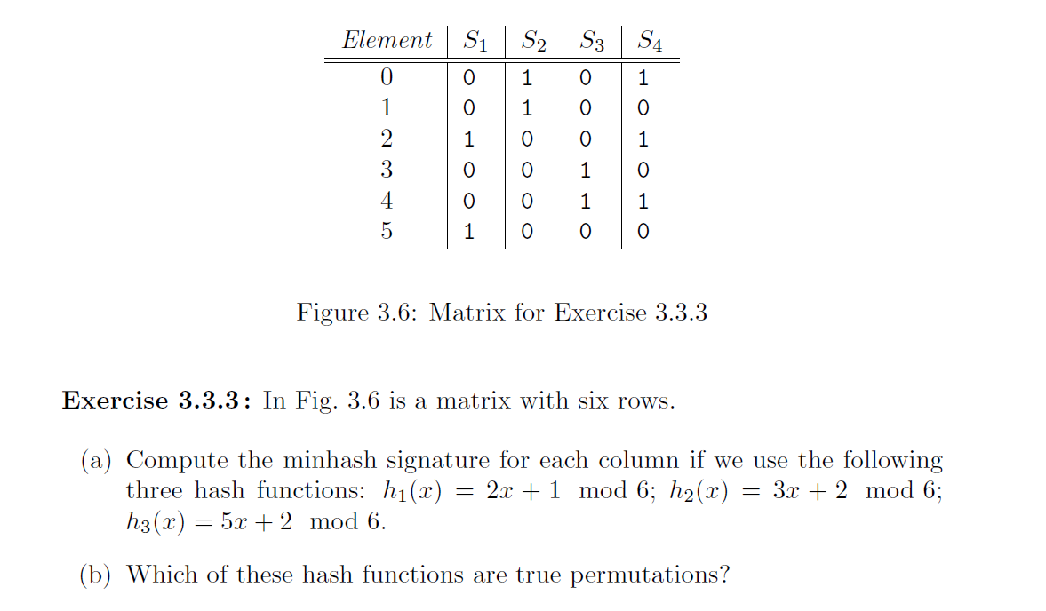

Locality-Sensitive Hashing for Documents (Minhash Signatures)
When we have millions of documents, comparing every pair of documents is too expensive.
Goal: Quickly find pairs of documents that are likely to be similar.
LSH does this by:
- Converting documents into MinHash signatures.
- Dividing signatures into bands.
- Only comparing documents that match in at least one band.

Suppose we use b bands of r rows each, and suppose that a particular pair of documents have Jaccard similarity s.
We can calculate the probability that these documents (or rather their signatures) become a candidate pair (If two documents have an identical band, they become a candidate pair) as follows:
- The probability that the signatures agree in all rows of one particular band is s^{r}.
- The probability that the signatures disagree in at least one row of a particular band is 1 − s^{r}.
- The probability that the signatures disagree in at least one row of each of the bands is (1 − s^{r})^{b}.
- The probability that the signatures agree in all the rows of at least one band, and therefore become a candidate pair, is 1 − (1 − s^{r})^{b}.

two docs become a candidate pair if they’re equal in any band.
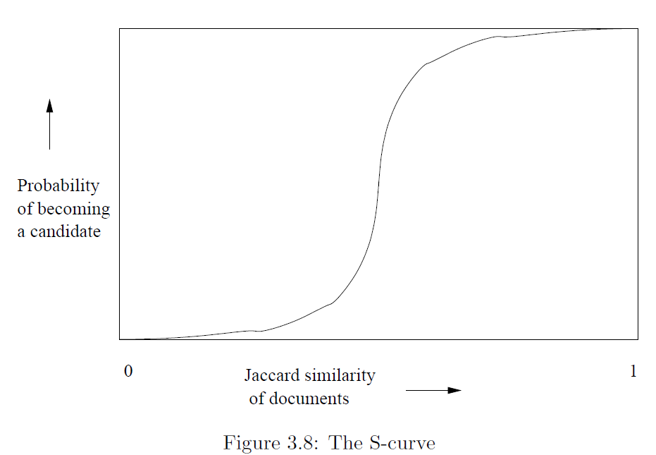
The threshold, that is, the value of similarity s at which the probability of becoming a candidate is 1/2, is a function of b and r. The threshold is roughly where the rise is the steepest, and for large b and r we find that pairs with similarity above the threshold are very likely to become candidates, while those below the threshold are unlikely to become candidates – exactly the situation we want. An approximation to the threshold is (1/b)^{1/r}. For example, if b = 16 and r = 4, then the threshold is approximately at s = 1/2, since the 4th root of 1/16 is 1/2.
Example
Let us consider the case b = 20 and r = 5. That is, we suppose we have signatures of length 100, divided into twenty bands of five rows each.

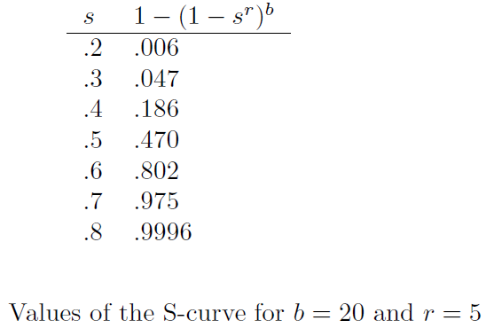

Steps to work with LSH
- Pick a value of k and construct from each document the set of k-shingles.
Optionally, hash the k-shingles to shorter bucket numbers.
- Sort the document-shingle pairs to order them by shingle.
- Pick a length n for the minhash signatures. Feed the sorted list to the algorithm to compute the minhash signatures for all the documents.
- Choose a threshold t that defines how similar documents have to be in order for them to be regarded as a desired “similar pair.” Pick a number of bands b and a number of rows r such that br = n, and the threshold t is approximately (1/b)^{1/r}. If avoidance of false negatives is important, you may wish to select b and r to produce a threshold lower than t; if speed is important and you wish to limit false positives, select b and r to produce a higher threshold.
- Construct candidate pairs by applying the LSH technique.
- Examine each candidate pair’s signatures and determine whether the fraction of components in which they agree is at least t.
- Optionally, if the signatures are sufficiently similar, go to the documents themselves and check that they are truly similar, rather than documents that, by luck, had similar signatures.
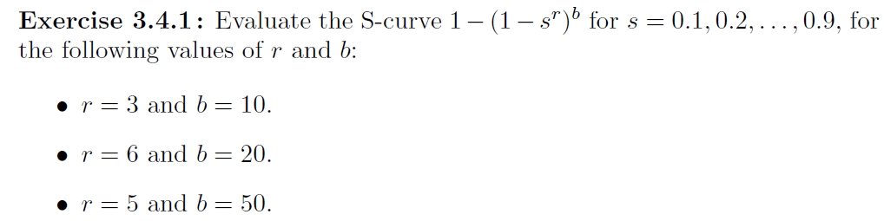

Locality-Sensitive Hashing (LSH) with MinHash Signatures Example

Step 1: Create k-Shingles

Document D1: 'data mining techniques are useful'
Document D2: 'data mining methods are useful'
Using k = 2 (word shingles):
D1 = {(data,mining), (mining,techniques), (techniques,are), (are,useful)}
D2 = {(data,mining), (mining,methods), (methods,are), (are,useful)}
Jaccard Similarity
Common shingles = {(data,mining), (are,useful)} = 2
Union size = 6
Jaccard Similarity s = 2/6 = 0.333

Step 2: Generate MinHash Signatures
Assume 12 hash functions are used.
Hash Function | D1 | D2
h1 | 2 | 2
h2 | 8 | 8
h3 | 1 | 5
h4 | 4 | 4
h5 | 7 | 7
h6 | 3 | 9
h7 | 6 | 6
h8 | 5 | 5
h9 | 2 | 8
h10 | 1 | 1
h11 | 4 | 4
h12 | 7 | 7
Signature(D1) = [2,8,1,4,7,3,6,5,2,1,4,7]
Signature(D2) = [2,8,5,4,7,9,6,5,8,1,4,7]
Matching positions = 9 out of 12
Estimated similarity = 9/12 = 0.75

Step 3: Divide Signatures into Bands
Let b = 4 bands and r = 3 rows per band.
Since b × r = 4 × 3 = 12, the signature can be divided into 4 bands.

Band 1:
D1 = (2,8,1)
D2 = (2,8,5)
No Match

Band 2:
D1 = (4,7,3)
D2 = (4,7,9)
No Match

Band 3:
D1 = (6,5,2)
D2 = (6,5,8)
No Match

Band 4:
D1 = (1,4,7)
D2 = (1,4,7)
Match

Step 4: Candidate Pair Generation
LSH Rule: Two documents become a candidate pair if they match completely in at least one band.
Since Band 4 matches exactly, D1 and D2 become a candidate pair.

Probability Formula in LSH
If document similarity is s:
- Probability all rows in one band match = s^r
- Probability a band does not match = 1 − s^r
- Probability all b bands fail = (1 − s^r)^b
- Probability of becoming a candidate pair = 1 − (1 − s^r)^b

Probability Calculation for This Example
From the MinHash signatures:
s = 9/12 = 0.75
b = 4
r = 3
- Probability that all rows in one band match:
P(one band matches) = s^r
= (0.75)^3
= 0.421875
≈ 42.19%
- Probability that a particular band does not match:
P(one band fails) = 1 − s^r
= 1 − 0.421875
= 0.578125
≈ 57.81%
- Probability that all four bands fail:
P(all bands fail) = (1 − s^r)^b
= (0.578125)^4
= 0.1117
≈ 11.17%
- Probability of becoming a candidate pair:
P(candidate pair) = 1 − (1 − s^r)^b
= 1 − 0.1117
= 0.8883
≈ 88.83%
Threshold Calculation
Threshold ≈ (1/b)^(1/r)
= (1/4)^(1/3)
≈ 0.63
Comparison with Actual Result
Estimated similarity = 0.75
LSH threshold = 0.63
Since:
0.75 > 0.63
the documents are expected to become a candidate pair.
Actual Observation:
Band 1 → No Match
Band 2 → No Match
Band 3 → No Match
Band 4 → Match
Since at least one band matches completely, D1 and D2 become a candidate pair.
Conclusion
The probability of D1 and D2 becoming a candidate pair is approximately 88.83%. Since their estimated similarity (0.75) is greater than the LSH threshold (0.63), LSH predicts that they are likely to become a candidate pair. This prediction is confirmed by the actual band comparison, where Band 4 matches exactly, causing the pair to be selected as a candidate pair.

Distance Measures
- Jaccard Distance
(1 – Jaccard Similarity)
- Euclidean Distances (L₂-norm)
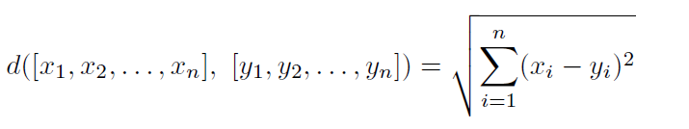
L_{r}-norm
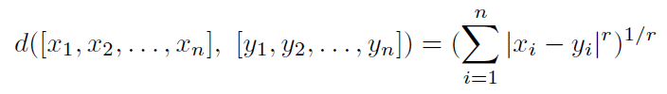
L₁-norm – Manhattan Distance $\sum_{i=1}^{n}{|x_{i}-y_{i}|}$
L∞-norm is defined as the maximum of $|x_{i}-y_{i}|$ over all dimensions i.

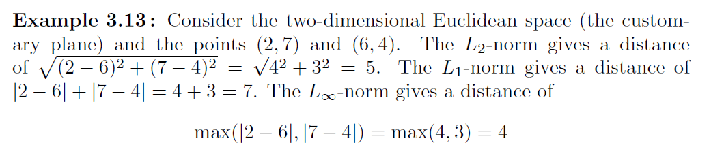

- Cosine Distance
Given two vectors x and y, the cosine of the angle between them is the dot product x.y divided by the L₂-norms of x and y (i.e., their Euclidean distances from the origin).
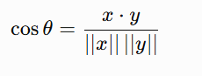
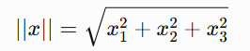
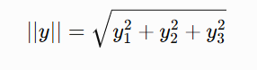

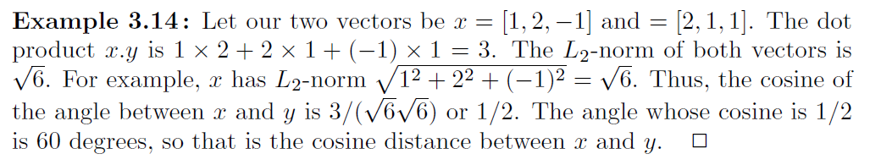

- Edit Distance
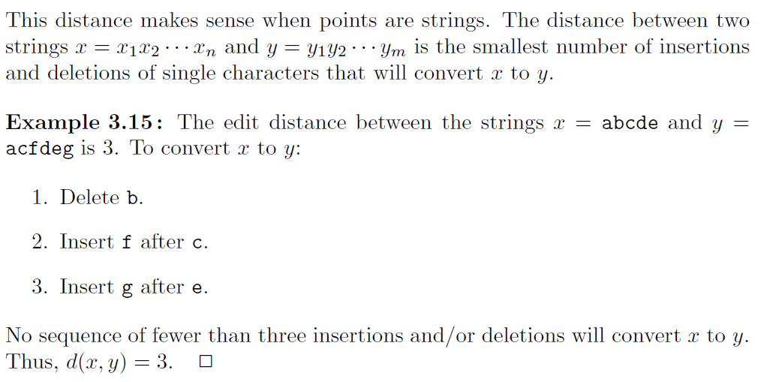
Another way to define and calculate the edit distance d(x, y) is to compute a longest common subsequence (LCS) of x and y. The edit distance d(x, y) can be calculated as the length of x plus the length of y minus twice the length of their LCS.

LCS(x,y)= acde, length =4, Edit distance= |x|+|y|-2(|LCS|)= 5+6-2(4)=3

- Hamming Distance
We define the Hamming distance between two vectors to be the number of components in which they differ.
The Hamming distance between the vectors 10101 and 11110 is 3.

Exercises
Exercise 3.5.4 : Find the Jaccard distance between the following pairs of the set:
- {1, 2, 3, 4} and {2, 3, 4, 5}.

Exercise 3.5.5 : Compute the cosines of the angles between each of the following pairs of vectors.
Also compute L₁-norm, L₂-norm and L∞-norm.
(a) (3,−1, 2) and (−2, 3, 1).
(b) (1, 2, 3) and (2, 4, 6).

Exercise 3.5.7 : Find the edit distances (using only insertions and deletions) between the following pairs of strings.
(a) abcdef and bdaefc.
(b) abccdabc and acbdcab.

Exercise 3.5.10 : Find the Hamming distances between each pair of the following vectors: 000000, 110011, 010101, and 011100.

